Project Design Phase-II Technology Stack (Architecture & Stack)

Date | 17th July, 2025
Team ID | LTVIP2025TMID56158
Project Name | TrafficTelligence: Advanced Traffic Volume Estimation with Machine Learning
Maximum Marks | 4 Marks

Technical Architecture:
The Deliverable shall include the architectural diagram as below and the information as per the table1 & table 2

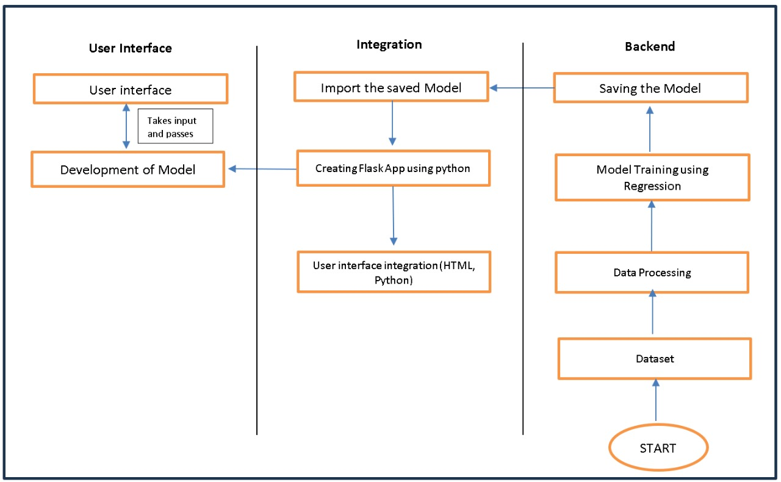

Table-1 : Components & Technologies:

S.No | Component | Description | Technology
1. | User Interface | Critical element designed for both Traffic Managers and everyday users, ensuring an intuitive and informative experience. | HTML, CSS, JavaScript
2. | Application Logic-1 | Involves a robust backend system responsible for processing, analyzing, and managing traffic data. | Python
3. | Database | Involves the storage and management of diverse traffic data for analysis. | File Manager, csv
4. | File Storage/ Data | Involves managing diverse types of data, including raw traffic data, machine learning models, and configuration files. | Local System, Google Drive
5. | Frame Work | It is a crucial part of our program as it is responsible for connecting the frontend with the backend. | Python Flask
6. | Machine Learning Model | The machine learning model is responsible for predicting future outcomes based on available data | Machine learning model created using regression algorithms
7. | Infrastructure (Server / Cloud) | Involves a combination of servers and cloud services to support the computational and storage needs of the application. | Local

Table-2: Application Characteristics:

S.No | Characteristics | Description | Technology
1. | Open-Source Frameworks | Open-source frameworks can accelerate development and ensure the reliability of TrafficTelligence, contributing to a more efficient and maintainable solution. | Python’s Flask

S.No | Characteristics | Description | Technology
2. | Scalability | Using cameras to collect data and to make models for specific locations. | Computer vision, dynamic databases.
3. | Performance | Regular performance testing, monitoring, and optimization are integral components of the development and maintenance processes, ensuring that TrafficTelligence consistently delivers timely and efficient traffic volume estimations. | R squared, Root mean squared error, Root Mean Square deviation
4. | Availability | Website can be made available all time in a webserver. This makes the website running without any issues | High speed Linux based webservers.

